OUTCOME BUDGET
2014-15

MINISTRY OF CULTURE

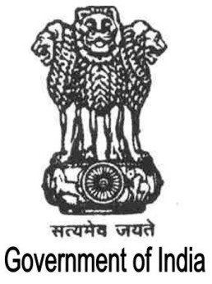

GOVERNMENT OF INDIA

CONTENTS

Executive Summary | i-iii
Chapter I | 1-14
Chapter II | 15-142
Chapter III | 143-149
Chapter IV-A | 150-296
Chapter IV-B | 297-450
Chapter V | 451-473
Chapter VI | 474-494

